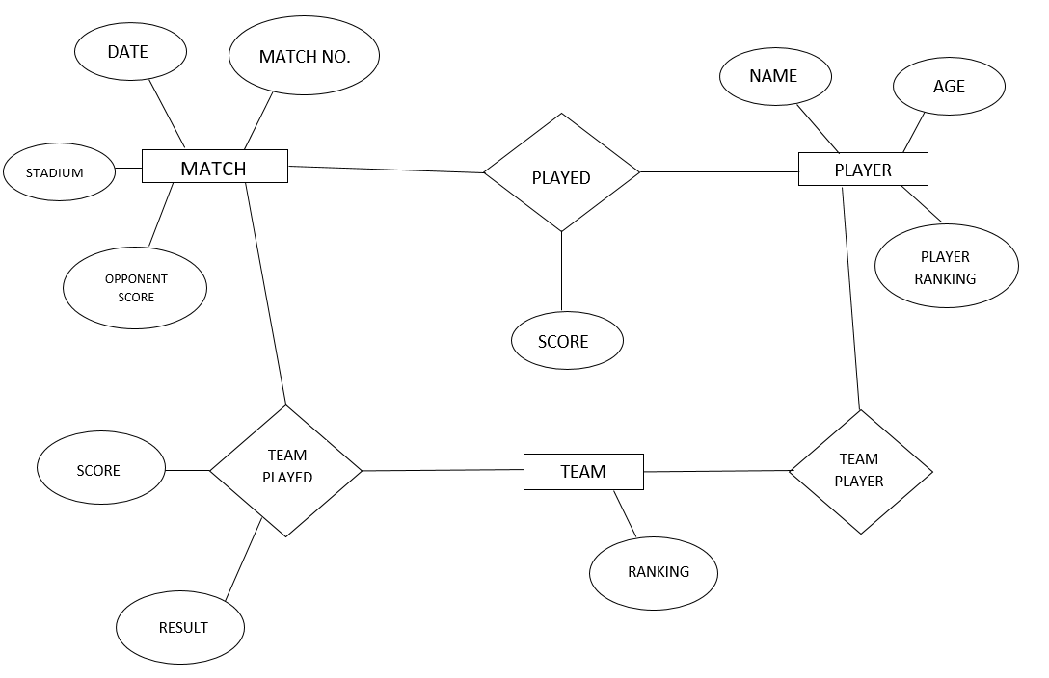

MATCH: PLAYER:

|  |  |  |  |  |  |  |
| --- | --- | --- | --- | --- | --- | --- |
| **COLUMN NAME** | **DATA TYPE** | **CONSTRAINT** |  | **COLUMN NAME** | **DATA TYPE** | **CONSTRAINT** |
| MATCH NO. | NUMERIC | PRIMARY KEY | NAME | VARCHAR(30) | NOT NULL |
| DATE | DATE | NOT NULL | AGE | NUMERIC | NOT NULL |
| STADIUM | VARCHAR(30) | NOT NULL | PLAYER RANKING | NUMERIC | NOT NULL |
| OPPONENT SCORE | NUMERIC |  |  |  |  |

TEAM PLAYED: TEAM: PLAYED:

|  |  |  |  |  |  |  |  |  |  |  |
| --- | --- | --- | --- | --- | --- | --- | --- | --- | --- | --- |
| **COLUMN NAME** | **DATA TYPE** | **CONSTRAINT** |  | **COLUMN NAME** | **DATA TYPE** | **CONSTRAINT** |  | **COLUMN NAME** | **DATA TYPE** | **CONSTRAINT** |
| SCORE | NUMERIC | NOT NULL | RANKING | NUMERIC |  | SCORE | NUMERIC | NOT NULL |
| RESULT | VARCHAR(10) | NOT NULL |  |  |  |  |  |  |